Access
At theholler.org website, from the ARI dropdown, select the icurio hyperlink; the following screen will be displayed:

Select the Login button and the following screen will be displayed:
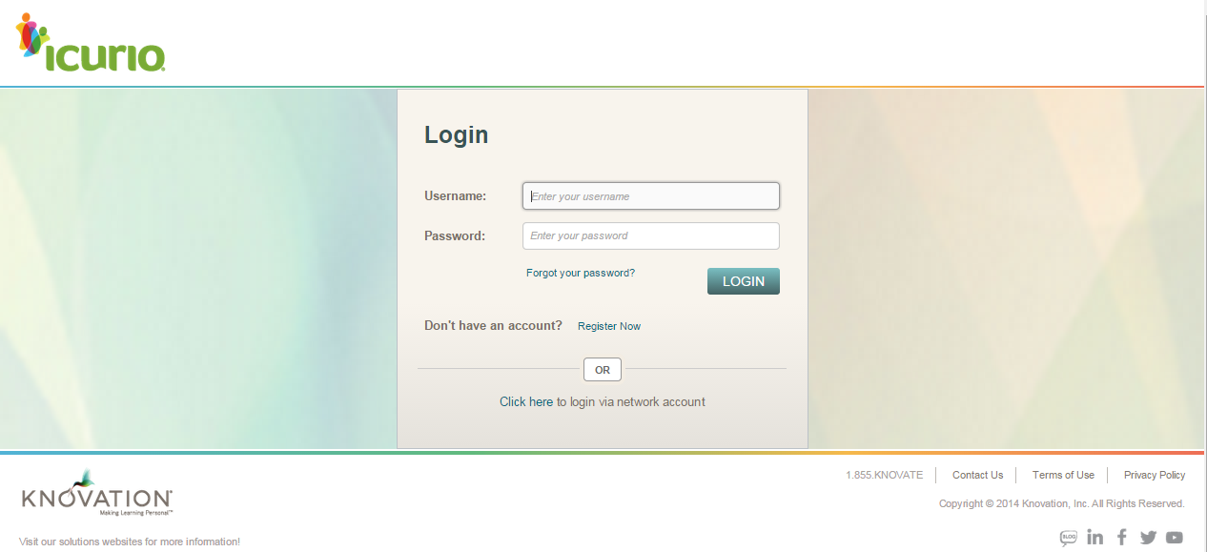

Existing Users: These are KVEC District & School users whose Username & Password was already set up by icurio; it applies to all roles (i.e. Administrators, Teachers, Students, etc.)

New Users: Work with your District KVEC administrator to set up Username & Passwords for multiple users / schools OR contact icurio directly via icurio support

Self Register: Your District KVEC administrator can provide a Registration Code that allows self registration; the Registration Code is very important as it associates your Username to the correct District & School.

Network Account: Do NOT use a network account.

