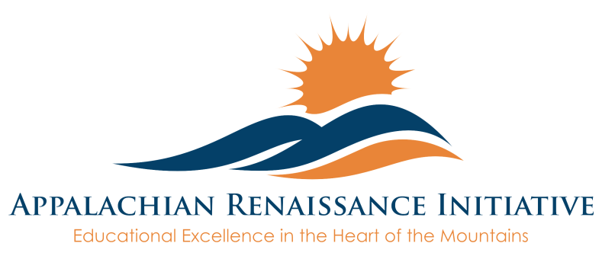

**NEXT GENERATION CLASSROOM ASSURANCE AGREEMENT**

**Objective of the Next Generation Classroom:**

* Part of the ARI Grant is to provide each school a next generation classroom that will be used to develop an intra-district network to provide students access to highly qualified teachers in other districts, dual credit courses, virtual courses, online curriculums, study guides, and other innovative ideas that will enhance learning.
* The next generation classroom will not be confined to the traditional school day, as it will be used to provide extended opportunities to students, and additionally offer teachers and staff professional learning experiences that extend beyond the school walls.

Each District will receive as part of the grant

* + Mobile 70” MondoPad that includes:
    - InFocus Touchscreen Tablet
    - Document Camera
    - Mounted Pan/Tilt/Zoom Camera for Video Conferencing and Digital Recording
    - $7000 to spend on 1 to 1 devices for use with MondoPad setup

**Training & Support Opportunities:**

* Each district will have the opportunity to attend trainings
  + 3 hour initial training offered by InFocus
  + 2 hour virtual trainings offered by InFocus/Lite the Nite Technology
  + Technical phone support offered by InFocus and Lite the Nite Technology
  + Training and support throughout the year by ARI staff

|  |  |
| --- | --- |
| **Section I – Contact Profile**  Each school receiving a next generation classroom is required to complete this agreement The ARI district innovation coordinator will be responsible for collecting and submitting completed forms. | |
| District |  |
| School |  |
| District Innovation Coordinator |  |
| Email |  |
| Phone |  |

|  |
| --- |
| **Section II – Next Generation Classroom Narrative**  Each school must submit a brief narrative describing how the next generation classroom will be used to enhance student achievement. Please describe the planned educational uses for the next generation classroom including special classes, virtual class offerings, or other 21st century learning opportunities. *Guiding Questions might be:*   1. *How will your school use next generation classroom equipment to enrich and deepen learning?* 2. *A significant capability offered by the next generation classroom equipment is the ability to record and send high quality video of instruction and the classroom setting. In what ways will the school utilize this video capability?* 3. *A wireless device (such as a laptop or tablet) for each student offers many more possibilities in efforts to enhance learning. How will your school use next generation classroom technology to enhance/personalize learning for students?* 4. *How will advances with instructional practice due to the use of next generation classroom equipment be shared among staff?* 5. *One aim of the Appalachian Renaissance Initiative is to help create and support collaboration among participating school districts (Breathitt, Floyd, Harlan, Hazard Ind., Jackson Ind., Jenkins Ind., Johnson, Knott, Lee, Letcher, Magoffin, Middlesboro, Owsley, Paintsville, Pike, Pikeville Ind., and Wolfe). How might your school use next generation classroom technology in collaborative efforts?* 6. *Are there other ways your school would utilize the next generation classroom that have not been shared?*   *Note: In an effort to aid schools and document use, an updated plan will need to be resubmitted at the end of each school year for the duration of the ARI grant (4years).* |
| Insert Narrative Here: |

|  |  |
| --- | --- |
| **Section III – Next Generation Classroom Assurances**  By signing this document, the district understands they must abide by the guidelines for the ARI Grant, but must also agree to following items. | |
| **1** | The district will ensure 1 to 1 student devices purchased with the $7000 per school will stay with the MondoPad for the ARI grant duration(Next 4 Years). The $7,000 per school may only be spent for device purchases and will be reimbursed by the ARI grant upon receipt of the district’s invoice. Devices must be purchased through a state bid list or local bidding process. |
| **2** | The district will ensure the MondoPad is made available during the school day, but also after school for extended learning with students, professional learning for staff, and possibly other adult learning opportunities. |
| **3** | The district will ensure the next generation classroom will be part of the district technology plan. |
| **4** | The district understandsthe use of equipment provided for the next generation classroom is based on the ARI Grant. Districts that do not fulfill the requirements set forth by the ARI Grant will be subject to equipment removal. |
| **5** | The district will ensure the Innovation Coordinator and teachers using the equipment attend available ARI sponsored training. |
| **6** | The district will ensure the next generation classroom and 1 to 1 devices are connected to the internet/network 24/7. |
| **7** | It is the districts responsibility to report malfunction or defect to InFocus and Lite the Nite Technology, as well as notify ARI technology staff. |
| **8** | Next generation classroom equipment remains the property of the ARI grant for its duration, upon which the district assumes ownership. |
| **9** | The district will fulfill their professional responsibility to actively seek outlets and participate in ARI sponsored events, which allow the sharing of professional learning as it relates to the use of next generation classroom technology. |
| **10** | The district will ensure next generation classroom equipment is used for classroom instruction and/or professional learning. |
| **11** | The district will actively seek ways to work collaboratively with other ARI school districts to share resources in ways that utilize next generation classroom equipment. |
| **12** | The district will complete documentation by the assigned date through mail and email. See page 5 for whom to send documentation. |

|  |  |  |  |
| --- | --- | --- | --- |
| **Section IV – Required Signatures** The undersigned, a duly authorized representative of the school district listed above, hereby certifies that the information set forth in this application has been reviewed and is true and correct to the best of the knowledge of the undersigned. We are committed to fully utilizing ARI next generation classroom equipment and ensure it will be available during and after school for innovative educational practices. We further agree to abide by all assurances as represented by this joint agreement between us and with the Appalachian Renaissance Initiative and KVEC. | | | |
|  | **Sign** | **Print Name** | **Date** |
| **Superintendent** |  |  |  |
| **CIO/DTC** |  |  |  |
| **District Innovation Coordinator** |  |  |  |
| **Principal of School** |  |  |  |
| **Finance Officer** |  |  |  |
| **SBDM Chairperson** |  |  |  |

**Please Submit as Indicated Below:**

1. **Mail the completed document with signatures:**

**ARI Grant: MondoPad Assurance Agreement**

**Jeff Hawkins, Ed.D.**

**Executive Director**

**Kentucky Valley Educational Cooperative**

**412 Roy Campbell Drive**

**Hazard, Kentucky  41701**

1. **Email the completed Word document with typed signatures to the following:**

[jeff.hawkins@hazard.kyschools.us](mailto:jeff.hawkins@hazard.kyschools.us)

[dessie.bowling@hazard.kyschools.us](mailto:dessie.bowling@hazard.kyschools.us)

[andrew.castle@johnson.kyschools.us](mailto:andrew.castle@johnson.kyschools.us)

[jeff.coots@jacksonind.kyschools.us](mailto:jeff.coots@jacksonind.kyschools.us)

[johnny.belcher@pikeville.kyschools.us](mailto:johnny.belcher@pikeville.kyschools.us)