**Ladibug Install for MondoPad**

The Ladibug document camera comes connected by HDMI to the MondoPad. To enhance the capabilities of the Ladibug document camera, teachers or technology staff will need to disconnect the HDMI cable and connect the USB cable located in the red bag. Once connected by USB, teachers will be able to capture images, videos, and annotate on documents that can be saved and shared to the whole class.

Step 1: Download the software: www.lumens.com.tw/

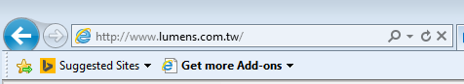’

Step 2: Type in the Search field: DC170 (This is the model of the document camera)

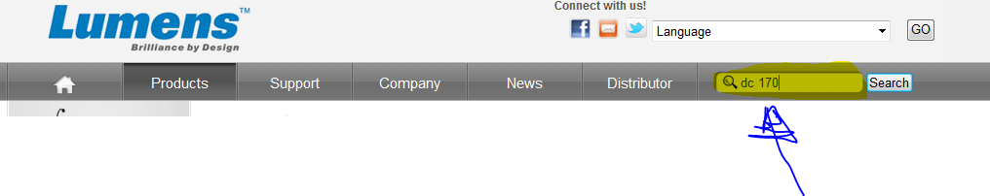

Step 3: Click on the DC170 Ladibug.

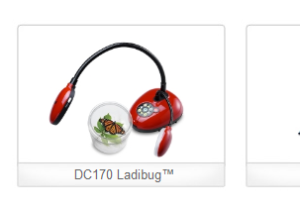

Step 4: The below page opens. Select “Download”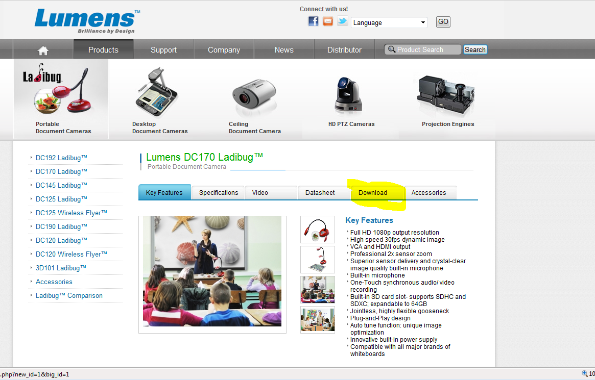

Step 5: Select “3. Software and Driver”

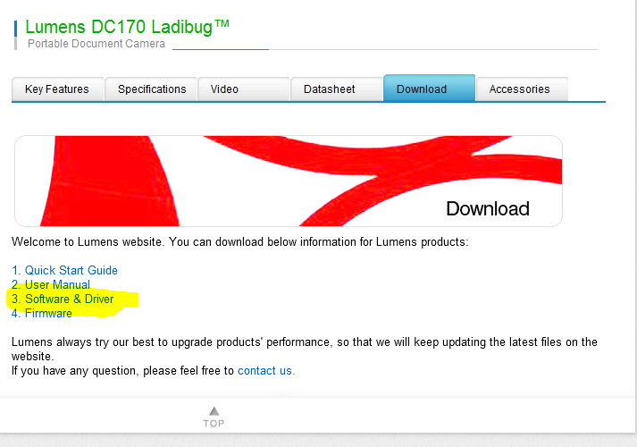

Step 6: Select DC170

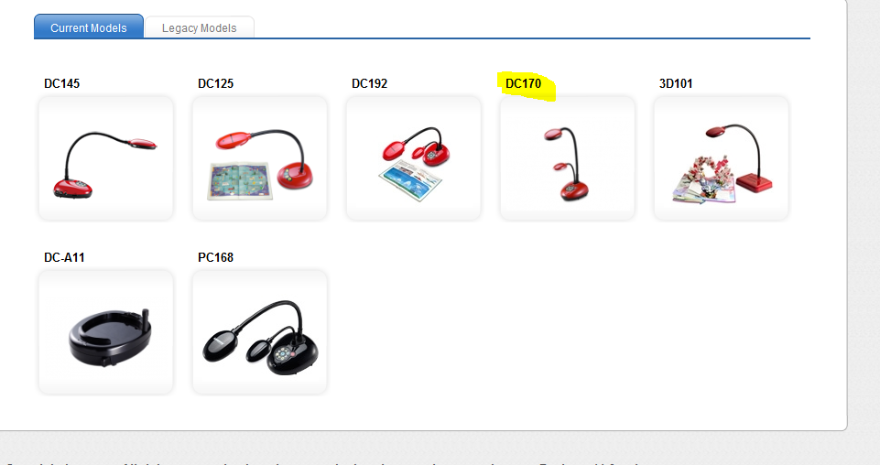

Step 7: Now select the “**Software & Driver Tab,”** then select the “**Ladibug PC 2.0 Exe**.” Click on the zip file icon under “Download” to start the download.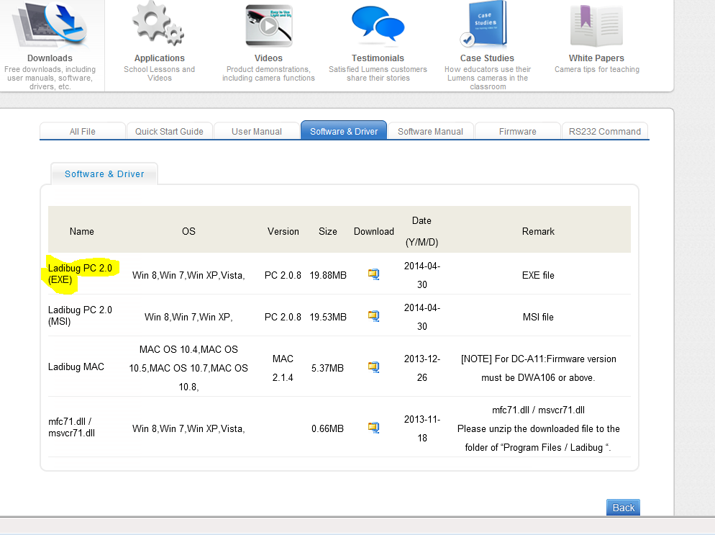

Step 8: Once the download starts it will ask you to either Open or Save. I selected Open.

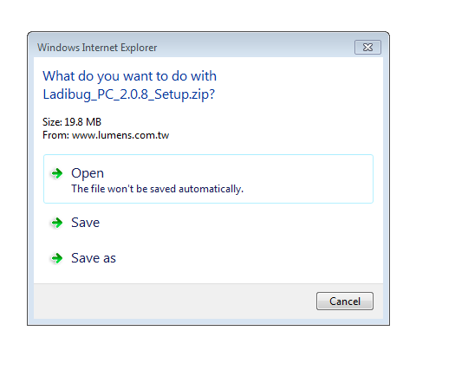

Step 9: You will see the bottom info about downloading 

Step 10: Once downloaded, you will see the downloaded file.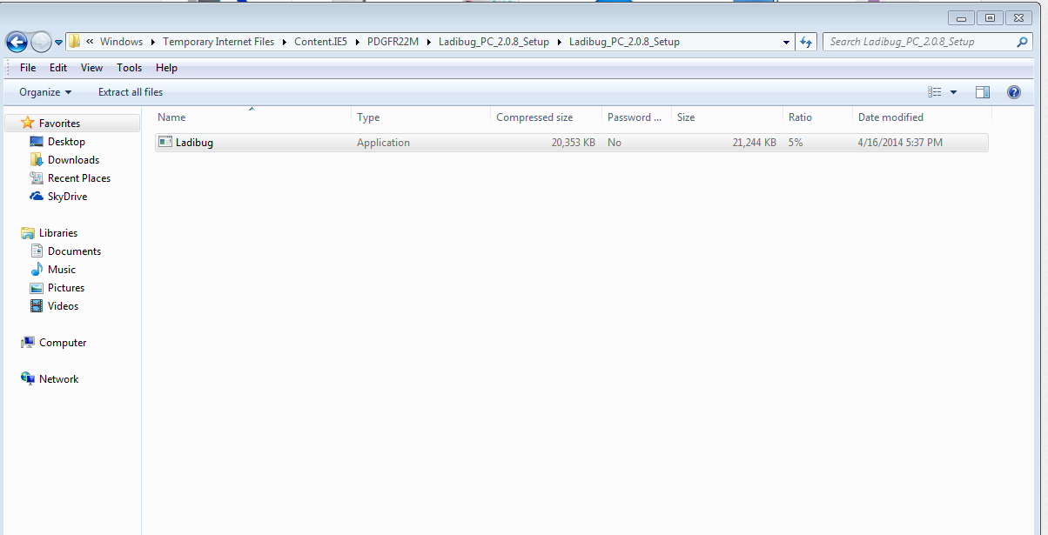

Step 11: Click on the Ladibug Application. Either “Extract all” or “Run.” I selected “Run”

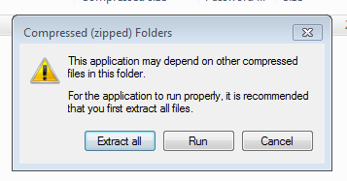

Step 12: Click “Run” on the screen below.

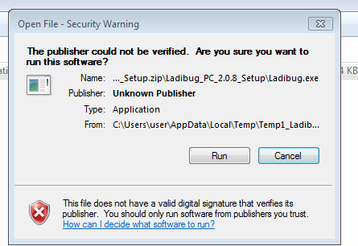

Step 13: Select English and click “Next”

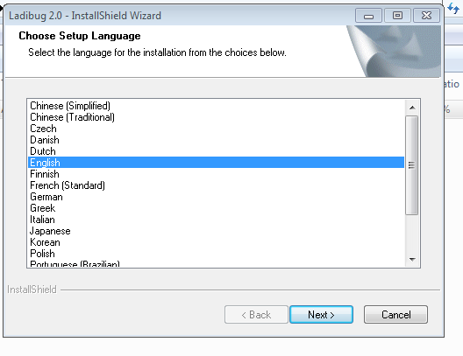

Step 14: Click “Next”

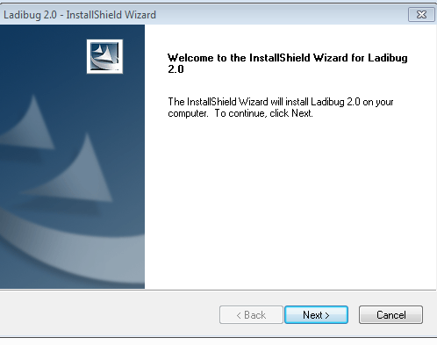

Step 15: Choose “Next” again.

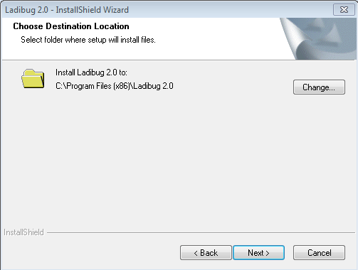

Step 16: Leave defaults the same in text boxes. Choose “Anyone who uses this computer (all users),” as seen below and then click “Next”

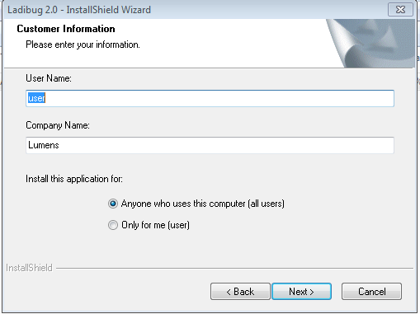

Step 17: Click “Install”

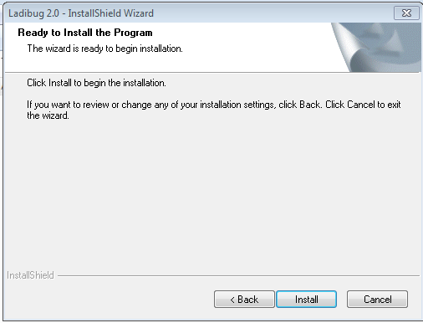

Step 18: Setup status will run below

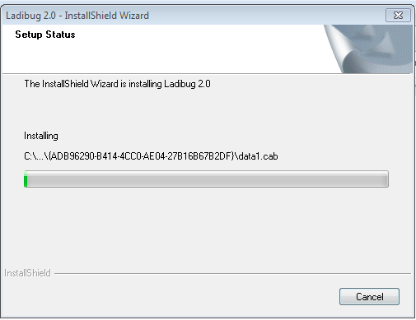

Step 19: Click “Finish”

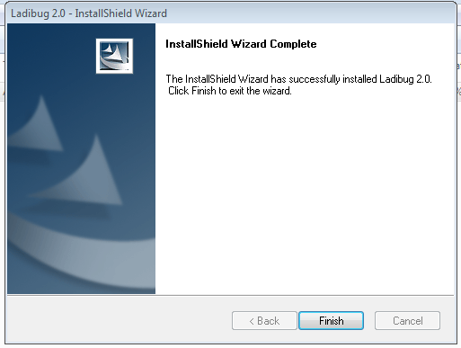

Step 20: If you want a shortcut on the desktop, click “Yes”

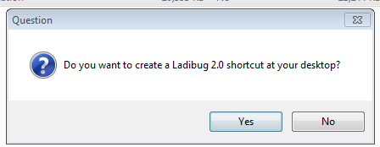

Step 21: The “Visual Presenter V2 Customer – InstallShield Wizard”, will start afterwards. Continue to Click through the setup. At the end you will be asked to restart the computer.

Step 22: Connect the USB cable between the Ladibug and the MondoPad.

Step 23: Restart the computer(MondoPad).