Virtual Lesson/Unit Plan Checklist

Planning for your lesson or unit
- What is your purpose?
- Can you clearly state what you plan to achieve with this lesson or unit?

Setting the Stage for your lesson |  | Resources
Step 1: Determine your Platform (Google Classroom, Zoom? How are you going to deliver a virtual lesson)?  - Google Meet  - Zoom  - Microsoft Teams  Guiding questions:  - Have you used the platform before?  - Rate your knowledge on this platform?  - What supports will you need?  Step 2: Establish Virtual Classroom Procedures  - How will students engage in your virtual classroom?  - How will students access materials  (model how to access resources multiple times)  - What materials/manipulatives with the students need?  - How will students be directed to ask questions?  - How will students submit their work?  - How will you plan for absent students?  - What are the Norms for your virtual classroom? |  | www.google.com  Video Call Protocol  Virtual Classroom Management
Step 3: Kentucky Academic Standards- kystandards.org

Start Here

Lesson goal(s)
- What do I plan to achieve in this lesson/unit plan?
Target(s)
- What standards am I addressing?
- What is my target(s)?
- What are the critical skills/content?
- What resources and tools will I need to teach the lesson/unit?

Step 4: Look at students IEP goals
IEP Goals - IEP Guidance Document
Guiding Questions:
- Does the goal(s) align with the Kentucky Academic Standards?
- How does this lesson connect to the student’s IEP goal?
- Does the goal have all the required components?
- Can I measure this goal? What the method of measurement?
Example:
When given a 5th grade writing assignment, Johnny will write a paragraph using a topic sentence and supporting sentences with a score of 3 on a 4 point rubric for 3 consecutive trials weekly.
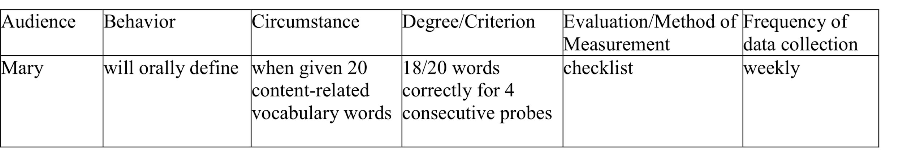
Step 5: Specially Designed Instruction |  | Resources
What the teacher does…..  Guiding Questions:  - What will you do to improve the performance of SWD?  - Do you have opportunities for increased practice turns and feedback?  - Do we practice retrieval of information from a blank slate?  - Do we practice flexible grouping for differentiation- (6-8 students)?  - Do we use Explicit Instruction that makes embedded explicit vocabulary instruction a priority?  - Do we embed activities that teach SWD metacognitive strategies?  - Fill in the gap interventions? preloaded strategies at grade level and on instructional level.  - Do we have strong research-based strategies for positive behavioural support for SWD?  - Do you use scaffolded instruction?  - Do you make use of mnemonics to aid SWD memorization skills?  - Does the SDI you list match the Annual Goal? |  | SDI Info- Graphic  John O'Connor Power Point for SDI -Great read for developing your list of SDI.  Practice Turns and Feedback  retrieval of information  Using Think, Pair, Share with Google Doc extend to Breakout Rooms  Virtual application: Spaced Repetition Look at the use of Quizlet flashcards. Apply the Google Calendar to set practice sessions that are spaced for improved memory.  Flexible grouping for differentiated classrooms  11 ways to do embedded vocabulary instruction  Reading Rockets :10 ways to teach vocabulary with Online Tools  Metacognitive Strategies Give this article a chance the goods are on page 7.  Mnemonic Strategies  Article: Mnemonics  Positive Behavior Site for the Classroom  10 ways to scaffold learning  Virtual Scaffolding of Google Lessons
Supplementary Aids and Services |  | Resources
What the student needs……  Guiding Questions:  - What are SAS does your Student With a Disability routinely require?  - Can you what you will provide based on student need? |  | IEP Lesson Plan and Development Handbook  List of Supplementary Aids and Services  Speech To Text  Text to Speech Extension on Google Chrome
Notes:

Explicit Instruction Lesson Plan
LESSON SECTION | CONTENT  What skills / knowledge to be taught today?  TOPIC: | Resources  Anita Archer's Explicit Instruction
I DO It….. | - Provide scaffolded learning  - Model activities  - Elicit frequent responses (verbal and written)  - Prepare lots of Examples and Non-Examples  - Check understanding (monitor and corrective feedback)  - Reteach if necessary | What Engagement Strategies will I use?  - annotation  - white board  - polls  - email  - reactions  - classroom Google doc
We Do It... | - Practice activities together  - Check understanding  - Monitor and provide corrective feedback  - Reteach if necessary
You Do It.... | - Independent practice of skill / knowledge  - Check understanding  - Monitor and corrective feedback  - Reteach if necessary | Feedback
Assessment | - How will you close your lesson?  - Target/Assessment match?  - Formative?  - Summative? | Revising the Definition of Formative Assessment
Progress Monitoring | - What is the measurable verb in the student’s goal?  - What is your method of measurement? (specific tool) | Methods of Measurement  List of Measurable Verbs
Teaching reflection and notes.  After lesson | Reflection Notes:  - What went well for your lesson?  - What changes need to be made to the delivery of instruction?  Feedback:  What worked well for your learning?  Areas for improvement or new learning?

