SPECIAL EDUCATION TRANSITION INNOVATION GRANT with a FOCUS on Drop-out Prevention, Retention & Persistence to Graduation
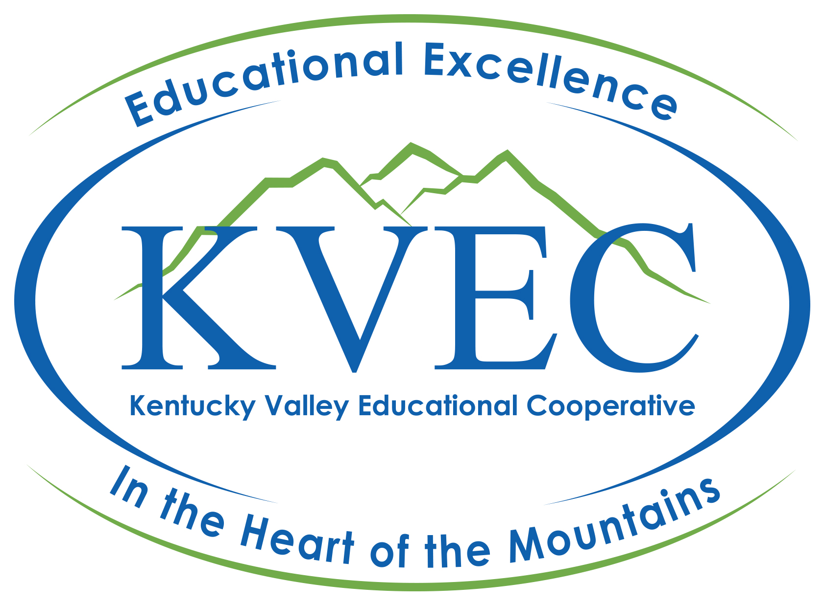

Applications Should be E-mailed to:

Will Kayatin, PhD
will.kayatin@hazard.kyschools.us
or
holler.org/application

Call or Text: (606) 854-4358

(ONLY E-mail receipt will establish deadlines.)

APPLICATION DUE: Wednesday, September 7, 2022
NOTIFICATION of Accepted Grant Applications on Monday, September 12

Applications will be scored by a panel that will use the scoring rubric on p. 11.

TRANSITION INNOVATION GRANT (TIG):
Historically the TIG initiative was designed to build an active and engaging learning environment in special education classrooms across the region that focus on practical solutions to authentic real-world challenges that enable educators to focus on transition for special needs learners – specifically targeting skills, professionalism, problem solving, confidence, adaptability, persistence, reliability, teamwork, communication, and self- direction. This TIG initiative is specifically designed to address drop-out prevention, retention, and persistence to graduation.
TIG enables regional educators directly serving special needs students to apply for a competitive grant to be used in their classroom (school if teamed approach) to develop an innovation strategy to engage students in transition focused learning that concretely connects the learner to demonstrating critical skills and abilities necessary for the workplace and to be productive citizens. The “innovative strategy” or strategies should inspire and motivate students to persist in school and graduate to post-secondary education and/or competitive employment.
Each grant recipient is required to participate in an action research component of the project and agree to present their conceptual model, findings, and results during the SPRING 2023 KVEC Special Education Conference & Exposition at Big Sandy Community and Technical College in Prestonsburg on Friday, April 28. Instead of fall presentations, Dr. Will Kayatin will visit teachers’ classrooms to provide feedback to strengthen and expand the innovation design. Spring presentations are designed to demonstrate the innovation and include students, products, designs, models, and exemplars so that the innovation can be made scalable and transportable.
All elements of each awarded project will be documented during the process with all materials (print, photo, audio podcast, video, etc.) stored and archived as open-source material on www.theholler.org.

A note about Action Research -
Action research is a practical approach to professional inquiry. As its name suggests, action research concerns actors – those people carrying out their professional actions (for our purposes, teaching and learning) from day to day - and its purpose is to understand and to improve those actions. It is about trying to understand professional action from the inside; as a result, it is research that is carried out by practitioners on their own practice, not (as in other forms of research), done by someone on somebody else’s practice. Action research in education is grounded in the working lives of teachers and students, as they experience them.
Action Research is about:
- the improvement of practice,
- the improvement of the understanding of practice,
- the improvement of the situation in which the practice takes place.
Carr, W. & Kemmis, S. (1986) Becoming Critical: education, knowledge and action research.

A KVEC Proposal must:
- Address practical solutions to authentic real-world challenges that enable educators to focus on transition for special needs learners – specifically targeting skills and characteristics that include professionalism, problem-solving, confidence, adaptability, persistence, reliability, teamwork, communication, self- direction, and self-advocacy.
- Pass through a competitive review process focused on the project's design.
- Grant recipients agree to present their work at the SPRING 2023 KVEC Special Education Conference & Exposition at Big Sandy Community and Technical College on Friday, April 28, Prestonsburg, KY.
- Grant recipients agree to work with district finance manager to submit invoices, packing slips and other financial documentation to support reimbursement of district proposal funds on or before business on Friday, October 14, 2022.
How can we responsibly promote untested, unproven, but innovative practices?
How can we encourage the inventors of innovations to start developing an evidence base so that over time these Transition Innovations can be held up to review and demonstrate their sustainability?
GUIDING QUESTIONS:
First, we practice transparency. The Transition Innovation Grants (focused on drop-out prevention, retention, and persistence to graduation) awarded through the KVEC are not yet tried and true. They have not yet been subjected to rigorous scrutiny or peer review. Applicants/Recipients attempt to describe the innovation in an informative and compelling way, while not making claims about its effectiveness until results can be measured and compared.
Second, we provide ongoing support for Transition Innovation Grant (focused on drop-out prevention, retention, and persistence to graduation) Proposal recipients. Once awarded a Transition Innovation Grant, educators are connected to a broad system of available supports that include regionally based staff, colleagues, and a growing virtual landscape focused through the lens of www.theholler.org.
Third, we encourage all grant recipients to use Action Research designs, so over time we can learn if these innovations are effective. We do not mandate a specific set of metrics or require a common model, believing that the dynamics in individual classrooms/initiatives require unique designs specific to needs and outcomes. We provide incentives for teachers to embed such studies into their project designs from the beginning as reflected in the scoring rubric.
Fourth, we will showcase and highlight the work of Transition Innovation Grants focused on drop-put prevention, retention, and persistence to graduation. Grant recipients are required to present their plan, findings, and results at the SPRING 2023 KVEC Special Education Conference & Exposition at Big Sandy Community and Technical College on Friday, April 28. Moving forward, the great work of teachers in the KVEC service region will be showcased through publications, web sites, and videos.
Fifth, we provide access to an online portal, www.theholler.org to review current grant recipients’ work. The video presentations from the SPRING 2023 KVEC Special Education Conference & Exposition at the college will serve as a resource for teachers region wide. Grant recipients are asked to post updates at least 3 times per year on the Holler site to encourage and inform their current colleagues and those who will follow their lead: October 28, 2022, and January 27 and March 24, 2023.

KVEC Transition Innovation Grant Application
with a FOCUS on Drop-out Prevention, Retention and Persistence to Graduation

Procedures and Requirements:

Educators in KVEC member districts are eligible to apply for the competitive Transition Innovation Grants. Educators may apply for up to $2,000 in proposal funds to implement innovative Transition strategies to improve post-secondary outcomes for students with disabilities.
Proposal applicants must show how they will support innovated practices to address drop-out prevention, retention and persistence to graduation which will positively impact post-secondary outcomes and/or competitive employment for students with disabilities. Middle and high school special education staff working within special education programs are eligible to apply.
A review team using the enclosed Scoring Guide will evaluate all submissions (p. 11).
On-going assistance will be available as needed by the KVEC staff and on www.theholler.org. Dr. Will Kayatin (Project Lead) will also make monthly visits to teachers’ classrooms for support and coaching.

Application requirements include:

- A complete submission of the application.

- Commitment to present your project and the impact at the SPRING 2023 KVEC Special Education Conference & Exposition at Big Sandy Community and Technical College on Friday, April 28 in Prestonsburg, KY.

- Commitment to actively participate for the entire day at the SPRING 2023 KVEC Special Education Conference & Exposition at Big Sandy Community and Technical College on Friday, April 28 in Prestonsburg, KY.

- Commitment to share project findings and results on the KVEC interactive WEB portal at www.theholler.org throughout the year.

*Please post updates on the Holler by October 28, 2022, and January 27 and March 24, 2023.

Required Dates for KVEC Transition Innovation Grant (TIG) with a focus on Drop-out Prevention, Retention and Persistence to Graduation
Wednesday September 23, 2022 | Deadline for Proposal Submission
Monday, September 28, 2022 | Notification of Proposal Award
Friday, October 14, 2022 | A final expense report will be due Friday, October 14, 2022. Invoices must be submitted with expense report. Incomplete expense reports will not be funded. Expense reports submitted after close of business on Friday, October 14, 2022 will not be funded.
Friday, April 28, 2023 | Present findings and results at the SPRING 2023 KVEC Special Education Conference & Exposition on Friday, April 28, 2023, at Big Sandy Community & Technical College in Prestonsburg, KY and participate in activities for the entire day.
October 28, 2022  January 27, 2023  March 24, 2023 | POST UPDATES on the HOLLER  *Oct. 28th update may simply include an overview and student receptiveness to the project.

APPLICATION COVER PAGE
(To be included with Application)
Applications must be submitted electronically with signatures. It is suggested that you request a read receipt with your submission.
Special Education Teacher’s Name: | Email Address:
Special Education Teacher Team Names:

Description of Your Learning Environment:

Middle School or High School Name: | # of Students with IEP’s
School Phone Number: | District:
School Address:

City: Zip Code:

Lead Teacher’s Cell Number:

Proposed innovations must be designed to build an active and engaging learning environment in special education classrooms that focus on practical solutions to authentic real-world challenges that enable educators to focus on transitions for special needs learners.
Kentucky Valley Special Educational Cooperative funding under this proposed project is intended to be used for providing resources for students with disabilities. These funds may not be used for general education purposes. Special education staff are encouraged to apply.
Application must be submitted by Wednesday, September 7, 2022
_________________________________________________________________________________________________________________________Grant Applicant Signature Date

_________________________________________________________________________________________________________________________Principal’s Signature Date

_________________________________________________________________________________________________________________________Director of Special Education Signature Date

Project Title (short, creative and on point):

KVEC Action Research Cycle for the Transition Innovation Grant

Step 1: Identify the area of focus and a research question relative to a focus on drop-put prevention, retention, and persistence to graduation. What is your problem of practice and how is it focused on improving student achievement and engagement to address student drop-out, retention, and persistence to graduation? (Identified in the Application Process)
Step 2: Learn more about your issue. (Individual and collegial examination independently)
Step 3: Develop your plan of Action- Explain how you are going to Systematically study the impact of a Specific strategy on a Specific problem. This is your Transition Innovation with a focus on drop-out prevention, retention and persistence to graduation. You will present your project overview, findings and results at the SPRING 2023 KVEC Special Education Conference & Exposition on Friday, April 28 at Big Sandy Community & Technical College in Prestonsburg, KY. Visit www.theholler.org to see previous presentations (albeit from KVEC’s Innovation Summits), click on SUMMIT tab-top right of screen.
Step 4: Implement Plan, Collect, and Analyze Data. This takes place during the school year.
Step 5: Communicate Results. This is the focus of the presentations on Friday, April 28 at the SPRING 2023 KVEC Special Education Conference & Exposition at Big Sandy Community & Technical College in Prestonsburg, KY.
Step 6: Continue Reflection and plan for a new cycle.

Application Requirements:
Please note that duplicate proposals/applications from multiple applicants will not be accepted or reviewed by the panelists. Please do not submit the same exact proposal from a prior year.

- Application Cover Page (starts on page 6).
- Area of Focus and/or Research Question- (What is your identified Problem of Practice for Transition with a focus on drop-out prevention, retention and persistence to graduation)
- Action Plan: (Minimum of 250 words) What will you implement to address the problem of practice? What resources are needed? Who is involved? How are your students actively involved, and please include examples of how students will be engaged in the project. What is the timeline? (Please remember you are Systematically studying the impact of a Specific strategy in transition with a focus on drop-out prevention, retention, and persistence to graduation).
- How will you evaluate your project outcome? What data/evidence will be collected; and how will it be evidenced? How will your project be sustainable, replicable, and/or scalable?
- Budget: Provide a budget narrative that defines proposal expenditures (page 11).
- Completed Project Summary and Digital Photo (p. 9 of application)
Project Summary

Below are eight guiding questions that may serve to develop a summary of your proposal.

Based on your response to these questions, write a brief summary of your proposal (a tightly constructed paragraph that compellingly describes your proposed project to your peers and the national and international audience. A digital photograph of yourself should also be submitted.

If your proposal is selected for funding, the summary and picture you submit will be used in the electronic program for the SPRING 2023 KVEC Special Education Conference & Exposition on Friday, April 28 at Big Sandy Community & Technical College in Prestonsburg, KY.

- What is your problem of practice that focuses on transitions with a focus on drop-out prevention, retention, and persistence to graduation for learners with disabilities – specifically targeting such skills and characteristics as: professionalism, problem-solving, confidence, adaptability, persistence, reliability, teamwork, communication, and self- direction? Other critical topical areas include the Pre-Employment Transition Services areas of: Career Exploration, Post-Secondary Counseling, Workplace Readiness Training (soft skills), Work-based Learning Experiences and Self-advocacy.

- How do you know this is a problem?

- What strategy will you implement this year to address the problem?

- What resources and personnel do you need to implement your strategy?

- What research question will guide your study of this innovation?

- What outcomes will prove that your innovation has succeeded?

- How will you measure those outcomes?

- How can you be sure that any positive outcomes on these measures are due to your innovation versus other factors?

APPLICATION DUE: Wednesday, September 7, 2022
Budget Narrative: Please attach a sheet(s) describing how the items you have identified in your budget relate to your problem of practice and activities purposed in the application. All items must have a direct impact on student success with a focus on drop-out prevention, retention, and persistence to graduation.
Projected Budget Detail:
Description of Item/Activity | Projected Amount

Total Amount Requested: ___________________________

- Project funds must be spent by October 14, 2022.
- A final expense report will be required on Friday, October 14, 2022. Invoices must be submitted with expense report. Incomplete expense reports will not be funded. Expense reports submitted after close of business on Friday, October 14 will not be funded.
- Travel and Substitutes are to be included in the $2,000 budget.
- Budgets that exceed $2,000 will not be considered for funding.
Scoring Guide KVEC Transition Innovation Grant (TIG)Proposal
 | 3 | 2 | 1
A.  Innovation | Proposal directly addresses innovation with the intent of improving transition for students with disabilities with a focus on drop-out prevention, retention, and persistence to graduation. | Proposal’s innovation may be stated or inferred and/or only minimal evidence is provided for improving transition for students with disabilities. | Innovation may be inferred but is not directly addressed to support its claim to improve transition for students with disabilities.
B.  Project  Goals | Goals for the project are clearly described and thoroughly documented; proposal supports innovative practices of the KVEC mission. The proposal supports transition with a focus on drop-out prevention, retention, and persistence to graduation for learners – specifically targeting skills and characteristics that include professionalism, problem solving, confidence, adaptability, persistence, reliability, teamwork, communication, and self- direction for students with disabilities.  Other critical topical areas may include the Pre-Employment Transition Services areas of: Career Exploration, Post-Secondary Counseling, Workplace Readiness Training (soft skills), Work-based Learning Experiences and Self-advocacy. | Purpose is stated and some evidence of need is provided. The proposal aligns with the Innovative practices of the KVEC mission. The proposal does not fully support transition for learners – specifically targeting skills, professionalism, problem solving, confidence, adaptability, persistence, reliability, teamwork, communication, and self- direction for students with disabilities. | Project’s purpose is unclear or does not address the Innovative practices of the KVEC mission. The proposal does not support transition for learners – specifically targeting skills, professionalism, problem solving, confidence, adaptability, persistence, reliability, teamwork, communication, and self- direction for students with disabilities.
C.  Project  Design | Project has a strong and innovative design with procedures and activities that are well defined, fully explained, and link to improving achievement and persistence to graduation for students with disabilities. Special education staff and students are actively involved in the work. | Project has adequate design with procedures and activities that are defined but somewhat lacks innovation. More teacher focused instead of student focused. | Project design is vague and not clearly linked to project goals or innovation. Program- based relying on software or hardware.
D.  Impact | Proposal describes the short- and long-term impact to students with disabilities, the school, the larger school community, and special education staff in terms of student achievement, drop-out prevention, and persistence to graduation. | Proposal describes impact but does so only in general terms. Specifics are lacking. | Proposal does not describe either short- or long-term impact or both.
E.  Plans for  Project  Evaluation | Proposal includes a variety of methods to evaluate the project. Transition outcomes are addressed regarding drop-out prevention, retention, persistence to graduation and improved post-secondary outcomes. | Proposal includes at least one method to assess participants or evaluate the project. | Proposal does not include any methods to assess participants or project. Or the methods are vague.
F.  Budget | Budget is complete and contains all required information. Budget is cost-effective and linked to activities and outcomes that will be sustainable. | Budget is complete but is not cost effective and/or related to activities and outcomes and does not address sustainability | Budget lacks required information or includes unallowable expenditures.
G. Sustainability | Proposal directly addresses sustainability and provides compelling evidence to support its claims. | Proposal’s sustainability may be stated or inferred and/or only minimal evidence is provided to support its claim | The proposal does not address or fails to provide evidence of sustainability

I acknowledge by initialing the boxes that I will:

deliver a 10–15-minute PowerPoint (and POSTER) at the SPRING 2023 KVEC Special Education Conference & Exposition on Friday, April 28 at Big Sandy Community & Technical College in Prestonsburg, KY, and participate in the entire day;
be part of an on-going support network on www.theholler.org, making posts at
least three (3) times during the school year by October 28, 2022, January 27, 2023 & March 24, 2023;
complete the appropriate paperwork for reimbursements and expenditures by
following established KVEC financial policies and procedures;
complete all requirements in a timely manner; and
submit a final expense report with invoices by Friday, October 14, 2022.

This completed form must be returned with the application or the application will not be considered.

I understand that by accepting this award, I agree to abide by the approved guidelines listed above.

______________________________________________________________________________________________________________
Signature of Lead Applicant Date

______________________________________________________________________________________________________________
Signature of Principal Date

_________________________________________________________________________________________________________________________Signature of Director of Special Education Date

The Transition Innovation Grant competition focuses on proposed transition strategies for students with disabilities in the KVEC School Districts with a focus on Drop-out Prevention, Retention and Persistence to Graduation.

